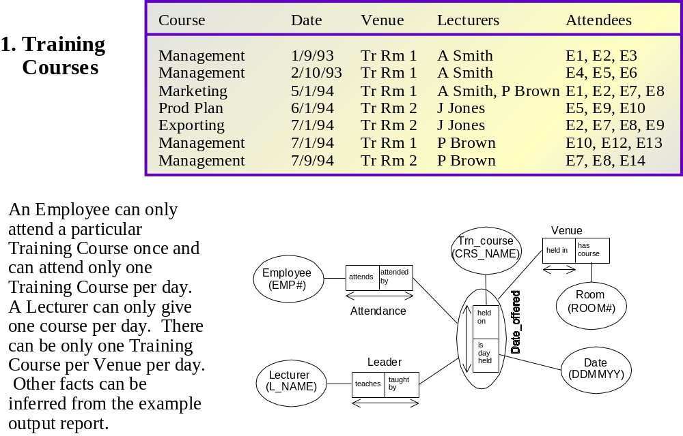

Room
(room#)
Attendance
Attended by
At
Attended
Offering
Employee
(Empl#)
Course
(CourseName
Date
(DD/MM/YY0
Lecturer
(Name)
On the
in
Offered
Of start
delivering
offered
Leader
Correct Schema

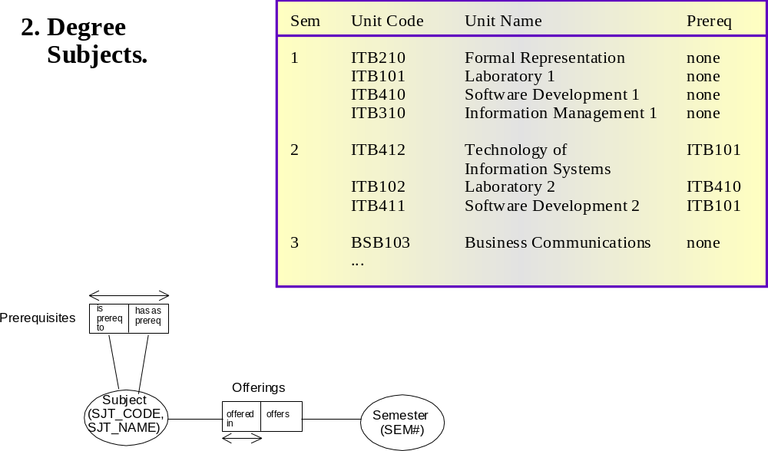

Room
(room#)
Attendance
Attended by
At
Attended
Offering
Employee
(Empl#)
Course
(CourseName
Date
(DD/MM/YY0
Lecturer
(Name)
On the
in
Offered
Of start
delivering
offered
Leader
Correct Schema

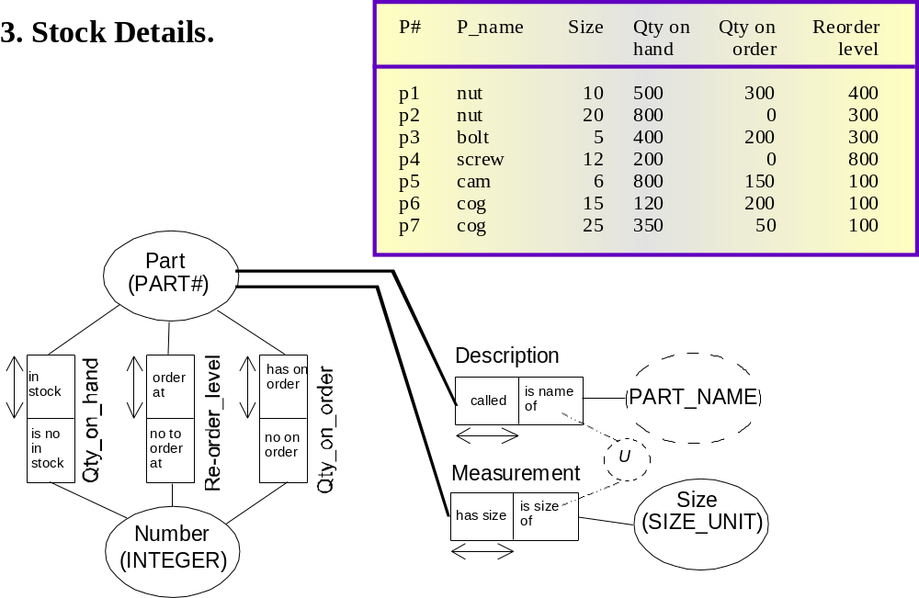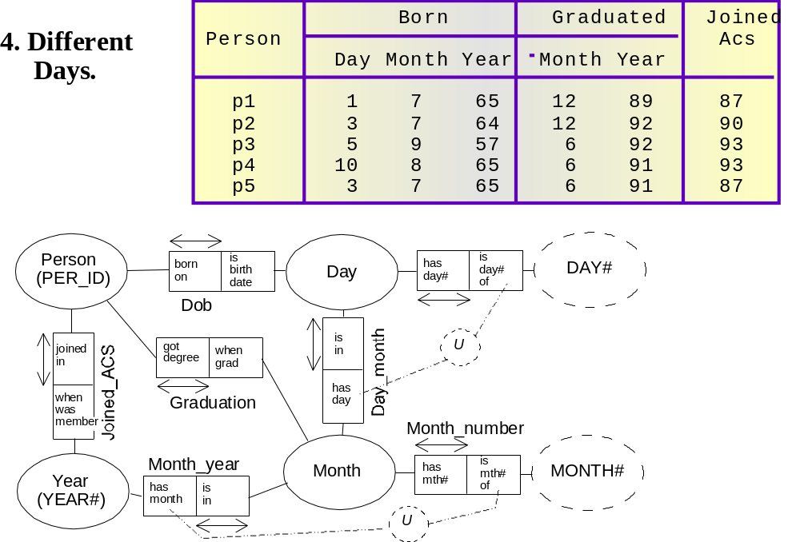
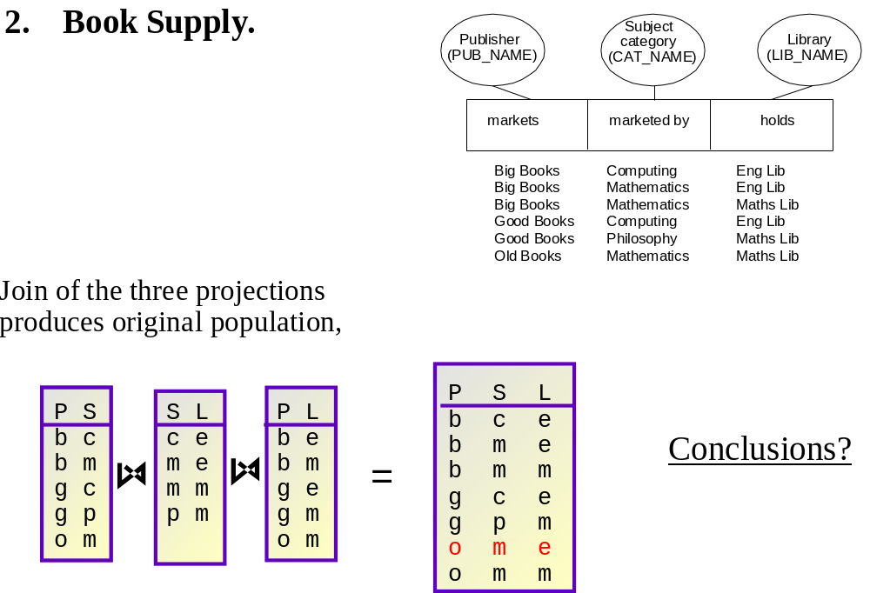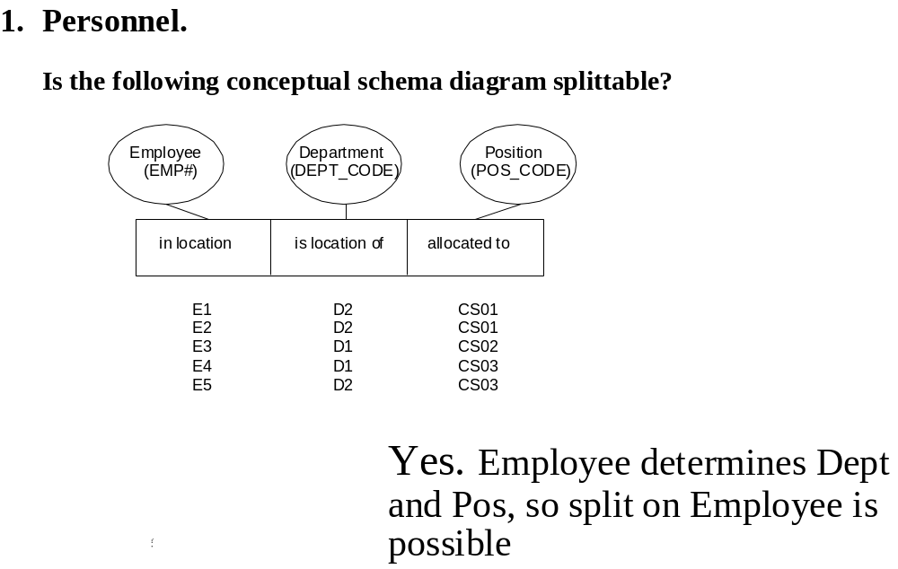
Problem 6
Book Supply
No join of any two projections on two columns produces original population of the fact type. Therefore, Split of this fact type into two fact types is impossible.
HOWEVER:
Problem 5
Is the following Fact Type splitable?
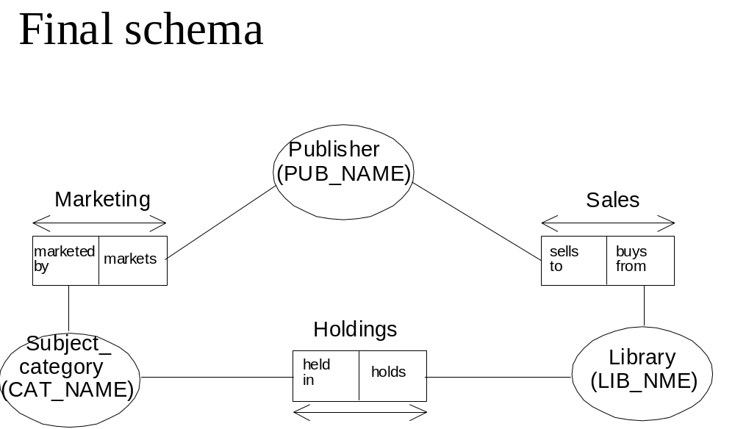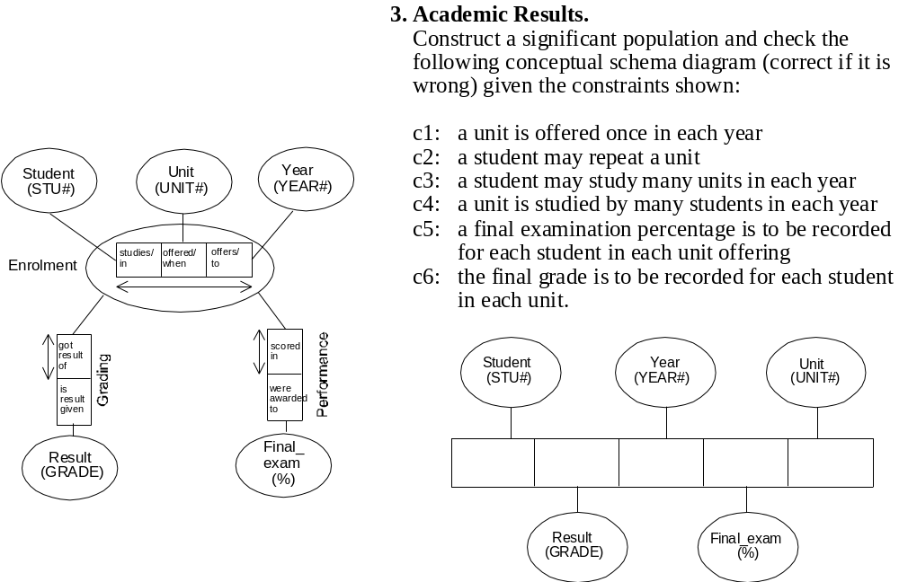
Problem 7
Academic results
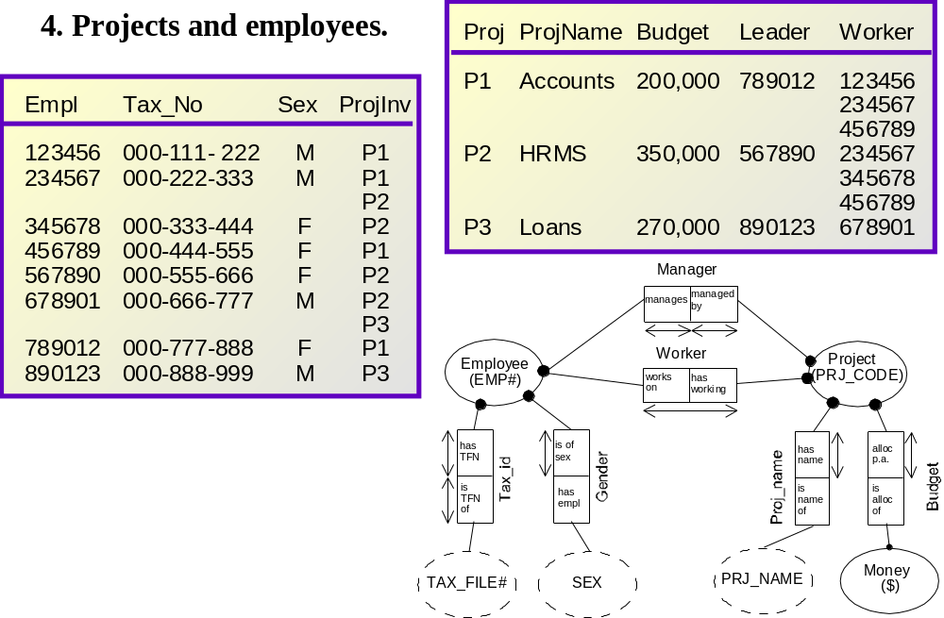
Problem 9
Employees and projects

Problem 1.
Employee Details
Employee | Department | Salary | Address
13416  24576  43658  98452  88774 | Sales  Accounts  Sales  Production  Production | 21,950  26,000  23,400  26,000  21,950 | 1 High St, Toowong  1 George St, City  6 Queen St, City  1 High St, Toowong  4 Rode Rd, Chermside
Employeee
Earns
Is earned by
Salary
Salarye
Works for
Employs
Work Location
Department
Lives at
Is home of
Domicile
Home
Of amount
Is amount of
Pay_Id
Dollars
Earns
Is earned by
Dept_Id
Dept_name
Located at
Is of
Home_Location
Address
Is identi-fied by
Identifies
Empl_Id
Empl#
Problem 2.
Vehicle repairs
Vehicle | Date | Cost
100ABC  100ABC  100ABC  200DEF  200DEF  300GHI  400JKL  900XYZ | 18/11/02  25/03/01  14/07/01  10/05/02  18/11/02  01/06/02  14/07/01  25/03/01 | 350.77  765.00  350.77  357.77  150.00  53.90  980.00  765.00

ZMA-s3-S
7
Vehicle
Vehicle repairs
Date
Money
Is the cost
Of
Repaired on/for
Is identi-fied by
Identifies
Vehicle_Id
Regl#
Ident. by
Is id of
Pay_Id
DD/MM/YY
Of amount
Is amount of
Pay_Id
Dollars
Vehiclee
Earns
Is earned by
Date
Is cost of
Money
For the cost
Vehicle repairs
Repair cost
Alternative
Approach
(with nested FT)

Problem 3.
Employee dates
Employee | Birth_date | Empl_start_date
123456  234567  345678  456789  567890  678901 | 21/06/60  18/07/55  29/03/55  20/08/65  21/06/60  16/12/72 | 05/09/83  20/04/86  04/07/90  04/07/90  16/12/72  02/01/92

Employeee
Born at
Is DoB of
Birth
Date
Started work
Of empl start
Empl_Commencement
Is Id of
Empl_ID
Is iden- tified by
Empl Id
Is cost of
DD/MM/YY
For the cost
Date
Id
Problem 4
Pest Control

Insect  Herb | Ants Aphids Cabbage Flies Mosqui- Potato Tomato  Moths Toes bug worm
Basil  Borage  Dead Nettle  Flax  Horse radish  Hyssop  Spearmint | X X  X  X  X  X  X  X X
Insect
Herb
Is control- led by
Controls
Pest Control
Is Id of
Pest_name
Is iden- tified by
Pest
Id
Is cost of
Herb_name
For the cost
Herb
Id

Problem 5
Employee | Department | Salary | Address
13416  24576  43658  98452  88774 | Sales  Accounts  Sales  Production  Production | 21,950  26,000  23,400  26,000  21,950 | 1 High St, Toowong  1 George St, City  6 Queen St, City  1 High St, Toowong  4 Rode Rd, Chermside
1. Employee Details

Employeee
Earns
Is earned by
Salary
Salarye
Works for
Employs
Work Location
Department
Lives at
Is home of
Domicile
Home
Of amount
Is amount of
Pay_Id
Dollars
Earns
Is earned by
Dept_Id
Dept_name
Located at
Is of
Home_Location
Address
Is identi-fied by
Identifies
Empl_Id
Empl#
2. Vehicle repairs
Vehicle | Date | Cost
100ABC  100ABC  100ABC  200DEF  200DEF  300GHI  400JKL  900XYZ | 18/11/02  25/03/01  14/07/01  10/05/02  18/11/02  01/06/02  14/07/01  25/03/01 | 350.77  765.00  350.77  357.77  150.00  53.90  980.00  765.00

9
9
Vehicle
Vehicle repairs
Date
Money
Is the cost
Of
Repaired on/for
Is identi-fied by
Identifies
Vehicle_Id
Regl#
Ident. by
Is id of
Pay_Id
DD/MM/YY
Of amount
Is amount of
Pay_Id
Dollars
Vehiclee
Earns
Is earned by
Date
Is cost of
Money
For the cost
Vehicle repairs
Repair cost
Alternative
Approach
(with nested FT)
10
Employeee
Born at
Is DoB of
Date
Started work
Of empl start
Empl_Commencement
Is Id of
Empl_ID
Is iden- tified by
Empl Id
Is format of
DD/MM/YY
Of format
Date Id
Birth
Employee
(Empl_Id)
Born at
Is DoB of
Birth
Date
(DD/MM/YY)
Started work
Of empl start
Empl_Commencement
ZMA-s3-S
3. Employee dates
Employee | Birth_date | Empl_start_date
123456  234567  345678  456789  567890  678901 | 21/06/60  18/07/55  29/03/55  20/08/65  21/06/60  16/12/72 | 05/09/83  20/04/86  04/07/90  04/07/90  16/12/72  02/01/92

4. Insect Control

Insect  Herb | Ants Aphids Cabbage Flies Mosqui- Potato Tomato  Moths Toes bug worm
Basil  Borage  Dead Nettle  Flax  Horse radish  Hyssop  Spearmint | X X  X  X  X  X  X  X X

Insect
Herb
Is control- led by
Controls
Is Id of
Pest_name
Is iden- tified by
Pest
Id
Herb_name
Herb
Id
Is Id of
Is iden- tified by
Problem 6
Employees and Managers.

Employee | Manager
Jones  Adams  Wong  Fegan  Crane  Bell G  Spencer  Bell A | Giles  Jones  Employeee  Emp_Id  Is Mana-  Ged by  Manages  Management  Jones  Giles  Bell G  Jones  Bell G  Jones

Problem 7
Employee information.

Name | DAddress | CompanyCar | Job Title
Brown  Smith  Santos  Wong  Ng  Nguyen | 1 George St  1 Queen St  1 Queen St  1 George St  78 Elizabeth St  15 Mary St | 400NRU  500NRU  100ABC  100BCD  500PQR  400NRU | Sales Rep  Sales Support  Manager  Clerk  Manager  Sales Rep

Employeee
Emp_Id
Empl as
Is job title of
Occupation
Position
(J_T_name)
uses
Is used by
Car Use
Car
(NReg#
Works at
Is location of
Dept Loc
DeptAddr
(H_Address)

Problem 8

Staff Offices

Floor | Room# | Staff Member
2  2  3  2 | 12  13  12  13 | Sally Wong  Tom Smith  Manual Barriga  Johann Schmidt

Employeee
Emp_Id
Has office In
Is office of
Office Location
Room
of
Floor
Is on
of
Room #
has
U
Problem 9
Employees and projects

Employee | Project | Total Allocation (hours) | HoursSpent
E1  E1  E2  E2  E3  E3 | P1  P2  P1  P2  P1  P2 | 50  50  65  35  50  35 | 24  26  13  15  25  26

Employee
(Empl#)
Allocated
to
Ihas allocation
Projedt
((proj#)
Is cost of
Time
(Hours)
For the cost
Total Alloc
Is cost of
For the cost
Time spent
Owner | Address | RegNumber | RegLetters | SpecPlate
Bill Brown  Sally Brown  Mary Jones  Helen Santos  Thom Santos  Peter Perfect | 1 George St  1 George St  15 Park Rd  22 Mary St  22 Mary St  77 Mary St | 100  100  100  202 | ABC  ABC  PQR  ABC | Wowser  Perfect
Problem 10 Vehicle registration

Owner
(name)
owns
Is owned by
Ownership
Care
Home
(address)
Is identified
Is part odf rego
RegoNumbers
RegoNunb
Is identified
Is part of rego
RegoLetters
RegoLetters
Is identified
identifies
SpecialRegoNumbers
SpecialPlate
Lives at
Identifies
Domicile
U
Problem 11 Medals on a Championship

Province | Medals
Province | Gold | Silver | Bronze | Total
Province W | 7 | 5 | 3 | 15
Province X | 2 | 2 | 9 | 13
Province Y | 3 | 1 | 3 | 7
Province Y | 4 | 0 | 2 | 6
…..

Province
(ProvId)
Achieved
Achieved
Silver
Medals
(No)
Achieved
Bronze
Gold
Achieved
* TOTAL
ORM Schema using binary fact types

ORM Schema using a ternary fact type

Province
RoviId)e
Earns
Is earned by
Medal Type
(colour)
Is number of
Number
(Int)
Has won
Achievement
Achievement Size
is number of
Number
(Int)
Has won
In total
Total Medals *
Typical fact is here:

Product A in Quarter 1 has reached 2.4 mln $US in sales.

If the year is required to the sale description, the verbalisation will be as follows

Product A in Quarter 1 of 2007 has reached 2.4 mln $US in sales.
Problem 13
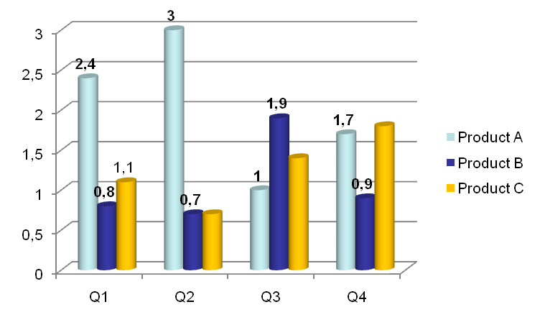

Product
(prod_Id)
Under sale
in
Quarter
(Q_No)
of
Value
($US)
Has reached
Sales
Sales Value
Product
(prod_Id)
Quarter
(Q_No)
Value
($US)
Under sale
in
Achieved for
Product Sales Value
Two schema options are presented: Flat – ternary fact type and nested.
Product
(prod_Id)
Under sale
in
Quarter
(Q_No)
of
Value
($US)
Has reached
Sales
Sales Value
If the year is desired, then the schema must be modified as follows .

Once again two schema options are presented
Year
(YYYY)
Product
(prod_Id)
Quarter
(Q_No)
Value
($US)
Under sale
in
Achieved for
Product Sales Value
in
in
Quarter
(Q_No)
Problem 13 (cont)

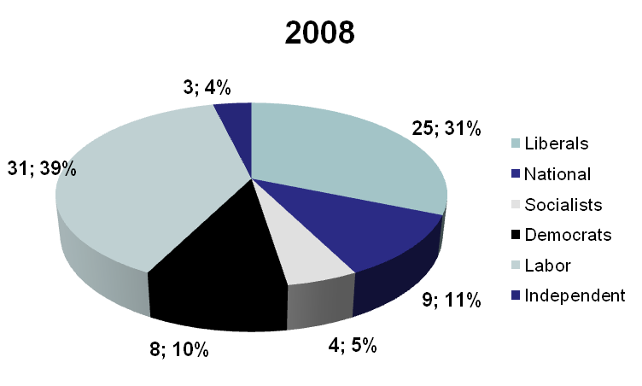
15
Typical facts are here:

The Labor party in 2008 year election has won 31 seats (in the Parliament)

The Democrats have 10% of seats in the Parliament after 2008 election

Note: the assumption is that there are no more than one election in a single year. If this assumtion is not valid, then other item of election identification could be added : eg 2008/E1 for the first election in 2008
Party
(party_name)
Participa-ting
in
Election
(Election_ID)
Elected
MPs
(No)
Has achieved
Participation
Election Result in %%
*
of
Participation
(%%)
Has achieved
Election Result
Problem 15

